Weekly Submission report
Name: Rishav Kumar Saw
Batch: B1_Python
Faculty: Kunal Sir

08/04
Problem 1
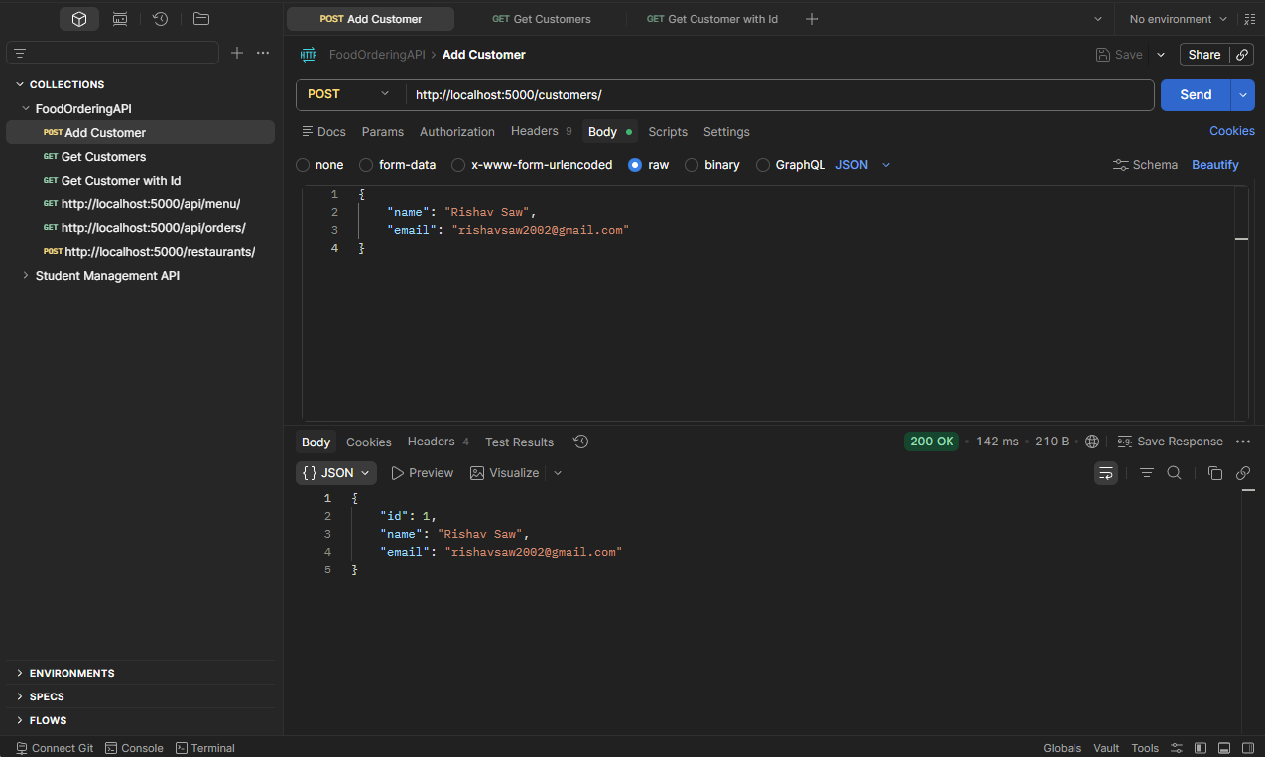
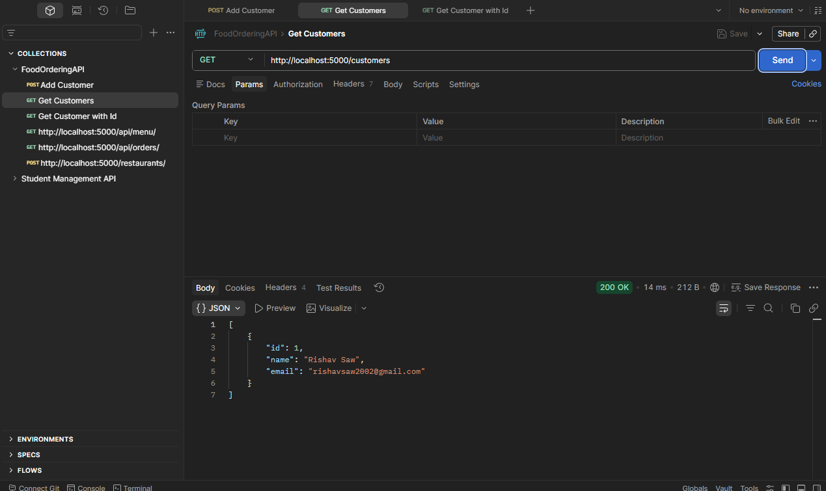
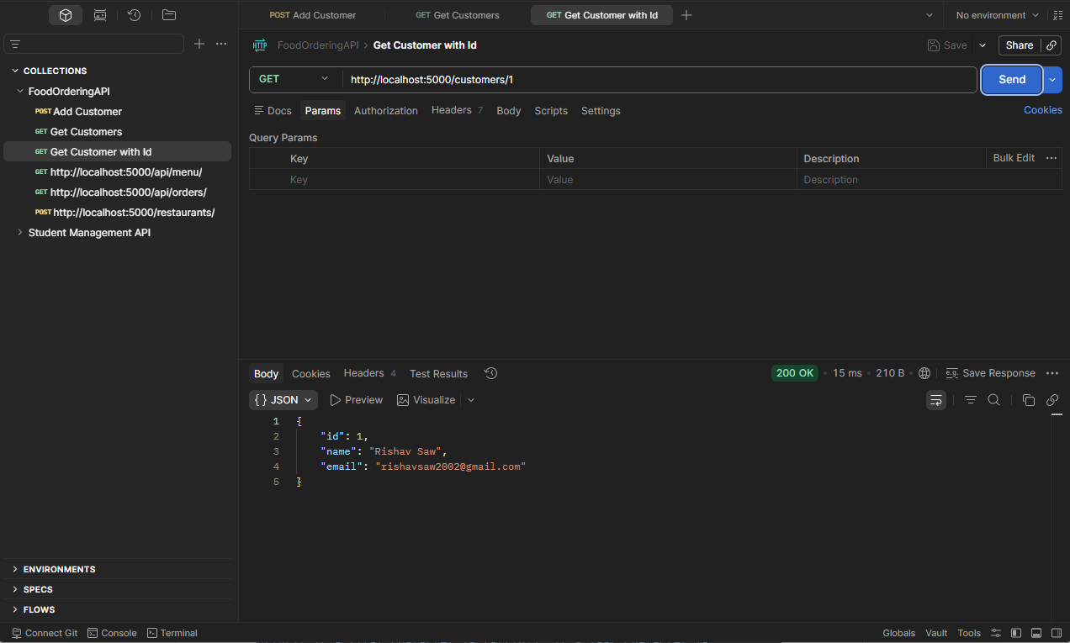

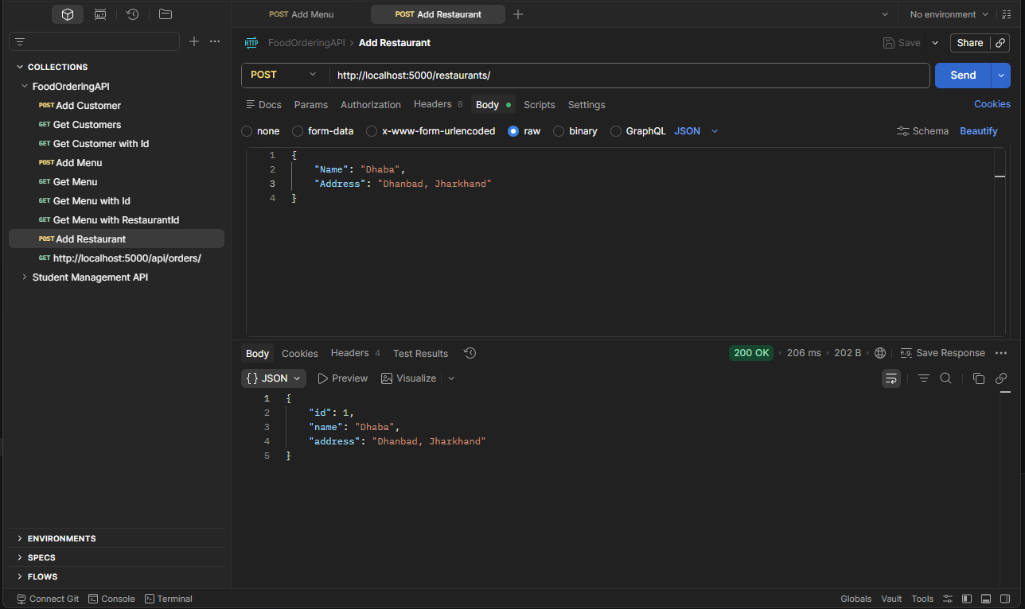
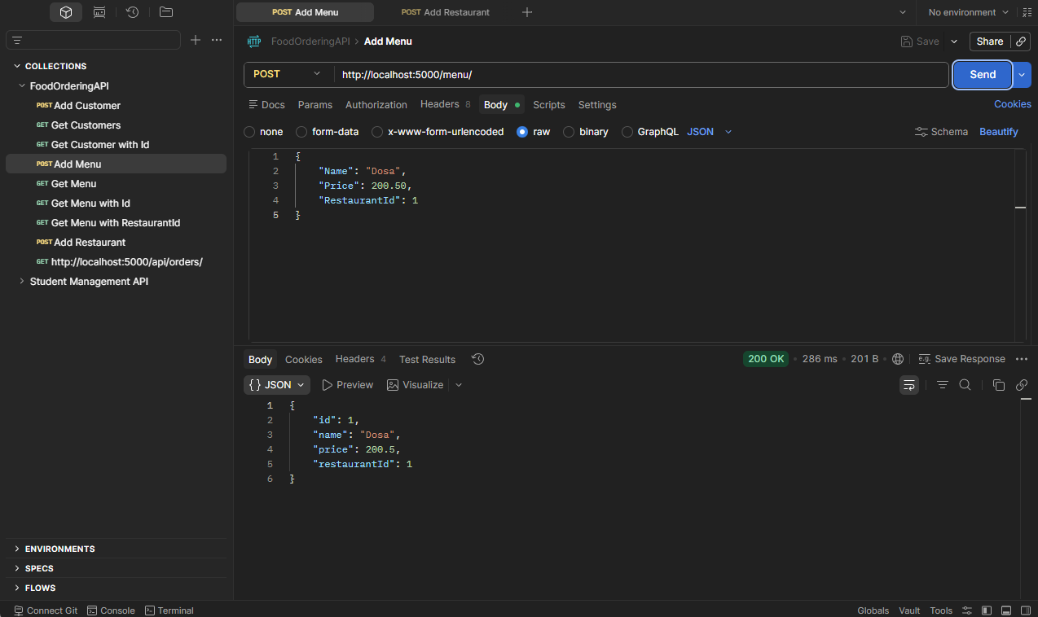

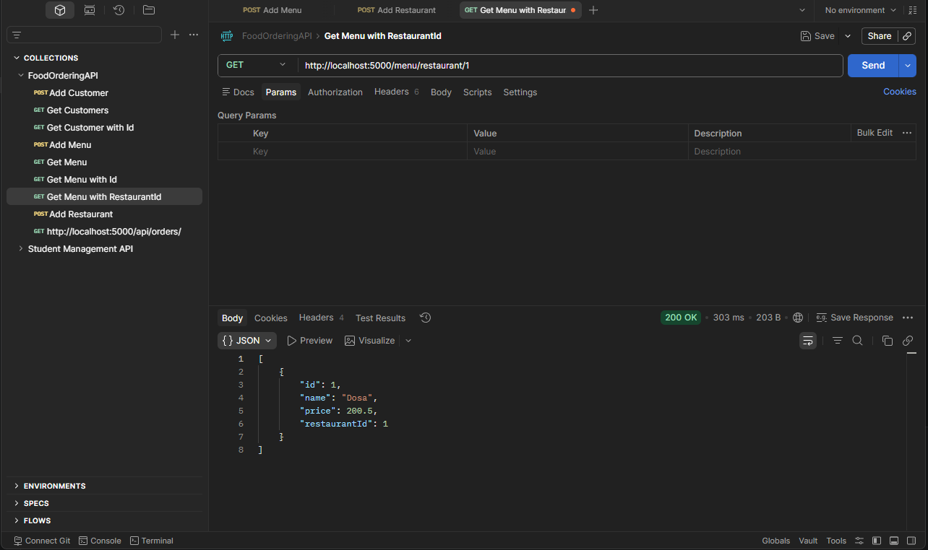
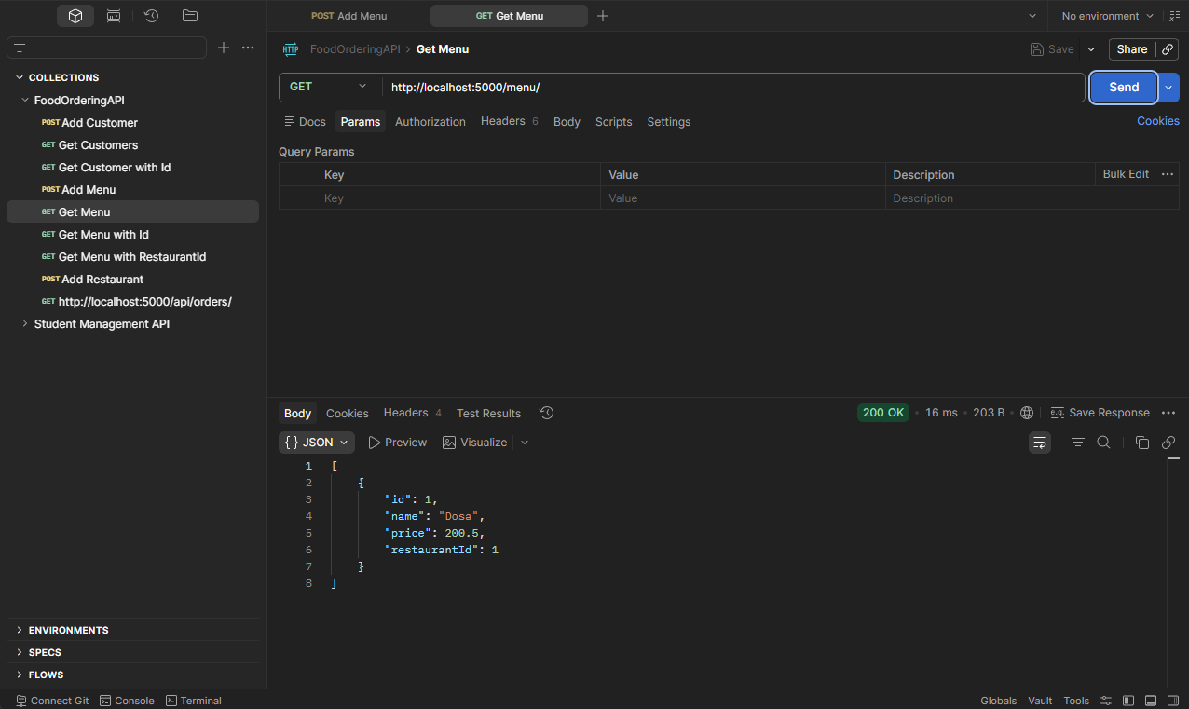

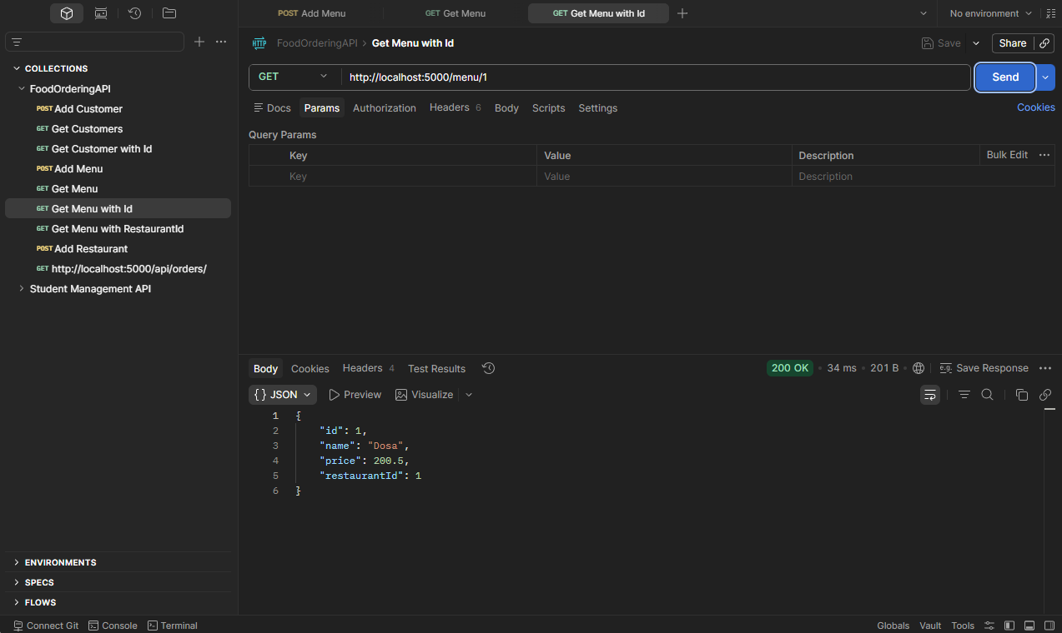
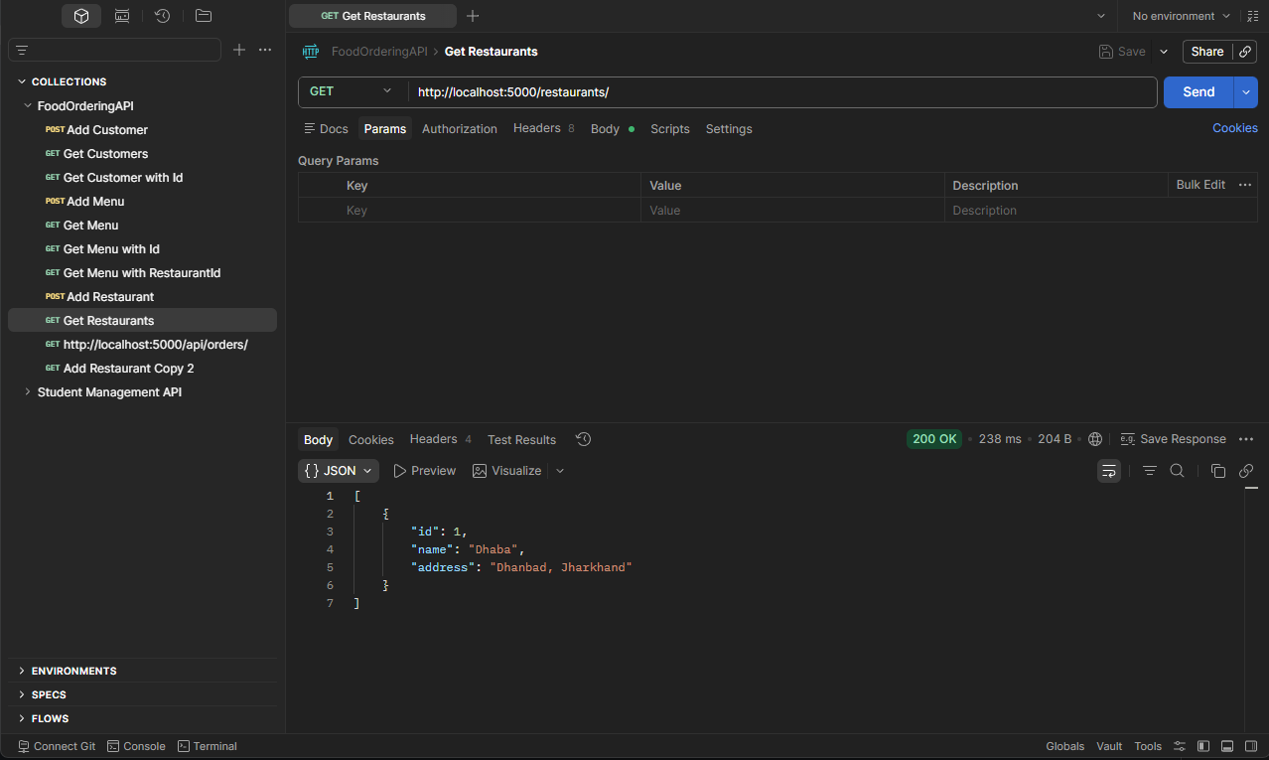

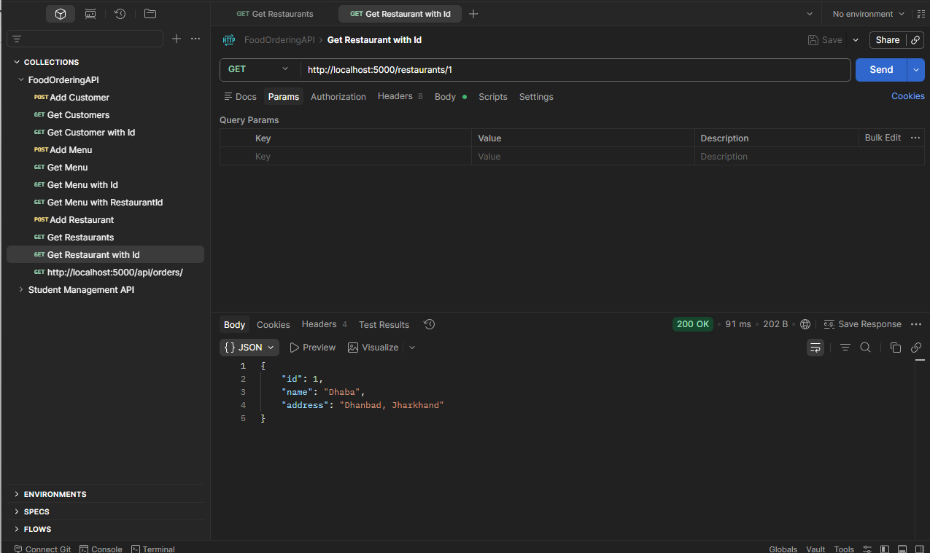
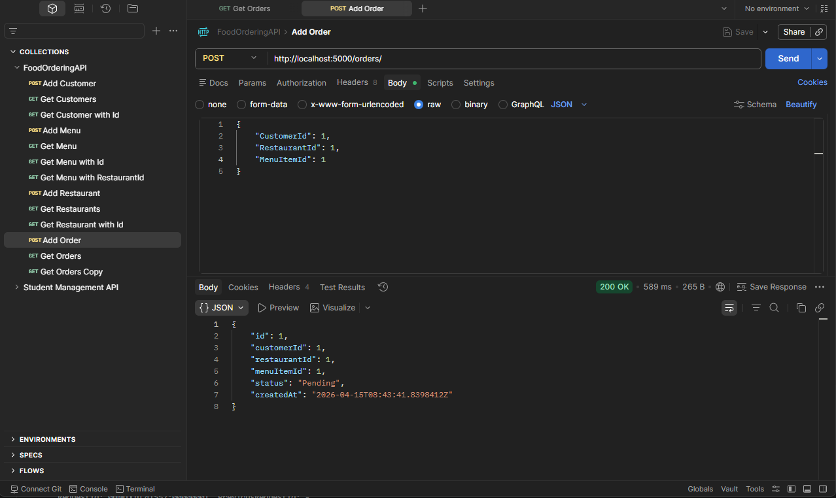

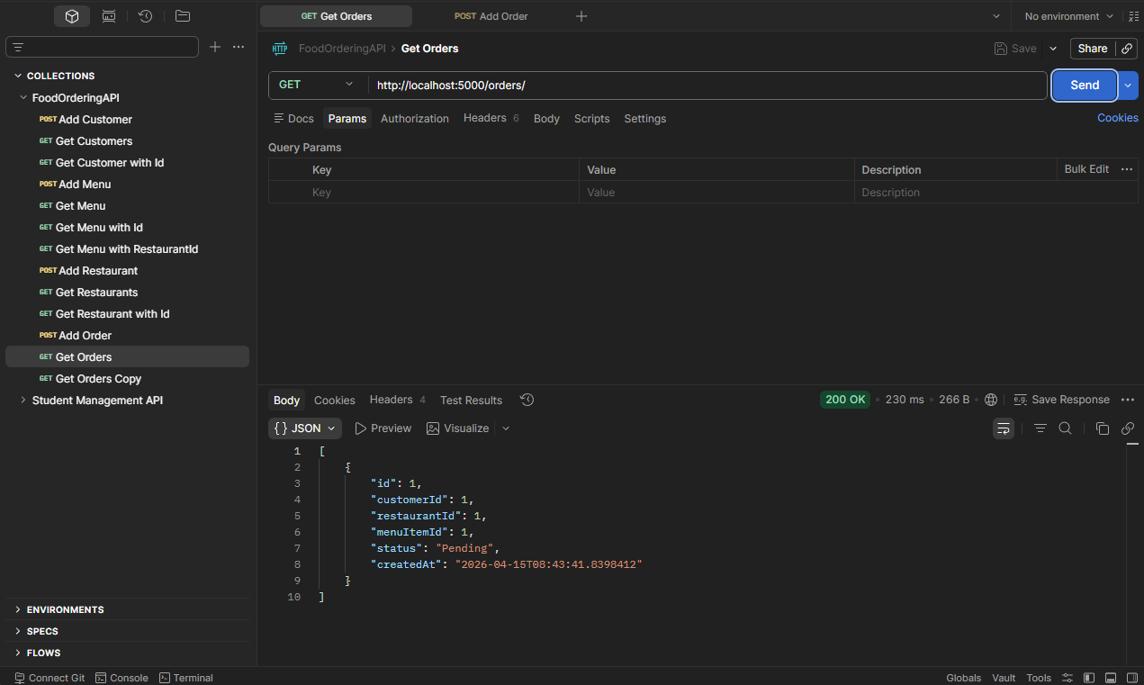

09/04
Problem 1

mkdir test1
cd mkdir
ls

Problem 2

touch a.txt b.txt c.txt

Problem 3

echo “Linux Practise” > a.txt

Problem 4

cat a.txt

Problem 5

cp -p a.txt copy_a.txt

Problem 6

mv b.txt new_b.txt

Problem 7

rm c.txt

Problem 8
mkdir data
mv a.txt data/

Problem 9

mkdir -p project/logs

Problem 10

ls -R

Problem 11

ls -l

Problem 12

chmod +x copy_a.txt

Problem 13

chmod -w copy_a.txt

Problem 14

echo “Hello World” > file.txt

Problem 15

echo “Second Line” >> file.txt

Problem 16
cat file.txt | grep “Hello”

Problem 17

wc -l file.txt

Problem 18

whoami

Problem 19

date

Problem 20

ps

Problem 21

nano hello.sh

#!/bin/bash
echo “Hello Linux”

chmod +x hello.sh
./hello.sh

Problem 22

nano user.sh

#!/bin/bash
echo “Current User= $(whoami)”

chmod +x user.sh
./user.sh

Problem 23

nano date.sh

#!/bin/bash
echo “Today’s Date= $(date)

chmod +x date.sh
./date.sh

Problem 24

name= “Rishav”
echo “My name is $name”

Problem 25

if[ -f file.txt ];then
echo “file.txt exists”
else
echo “file.txt doesn’t exists”
fi

Problem 26

for i in 1 2 3 4 5;do
echo $i
done

Problem 27

nano greet.sh

#!/bin/bash
echo "Hello $(whoami) Today is $(date)"

chmod +x greet.sh
./greet.sh

Problem 28

touch fle1.txt file2.txt file3.txt

echo "I love Linux" > file1.txt
echo "Bash is powerful" > file2.txt
echo "Practice makes perfect" > file3.txt

mkdir myfolder

mv file3.txt myfolder/

cat file1.txt

10/04
Problem 1
x= int(input("Enter a number: "))
print(f"It's square is {x*x} and it's cube is {x*x*x}")

Problem 2
str= input("Enter String: ")
print(f"It's first character is {str[0]}, it's last character is {str[len(str)-1]}")

Problem 3
print("The numbers divisible by 3 in the specified range are:")
for i in range(1, 21):
if(i%3 ==0):
print(i)

Problem 4
x=int(input("Enter first number: "))
y=int(input("Enter second number: "))
z=int(input("Enter third number: "))
if (x>y and x>z):
largest=x
elif(y>x and y>z):
largest=y
else:
largest=z
print(f"The largest number is {largest}")

Problem 5
def CheckIt(num):
if num>100:
return True
else:
return False

print(CheckIt(105))
print(CheckIt(99))

Problem 6
nam= input("Enter name: ")
def greet(name):
if(name== "admin"):
print("Welcome Admin")
else:
print("Welcome User")

greet("admin")
greet(nam)

Problem 7
arr=[1,2,3,4,5,6,7,8,9,0]
leng=0
for i in arr:
leng+=1
print(leng)

Problem 8
num= int(input("Enter the number whose table you want to be printed: "))
for i in range(1, 11):
print(f"{num} * {i} = {num*i}")

Problem 9
arr=[5, 10, 15, 20, 25]
count=0
for i in arr:
if i>10:
count+=1

print(f"Count of numbers greater than 10 is {count}")

Problem 10
word= input("Enter a word: ")
for i in range(0,5):
print(word)

Problem 11
num=[1,2,3,4,5,6,7,8,9,10]
filteredNum=[]
for i in num:
if(i%2!= 0):
filteredNum.append(i)

print(filteredNum)

Problem 12
import math
def checkPrime(num):
x= math.floor(math.sqrt(num))
for i in range(2, x):
if(num%i ==0):
return False
return True

print(checkPrime(1))
print(checkPrime(5))
print(checkPrime(27))
print(checkPrime(19))

Problem 13
arr=[1,2,3,4,5,6,7,8,9,10,15,14,13,12,11]
max=0
secondMax=0

for i in arr:
if i> max:
secondMax= max
max= i
elif i> secondMax:
secondMax=i

print(f"Second maximum number in the list is: {secondMax}")

Problem 14
word="qwertyuiop"
countV=0
countC=0

for i in word:
if(i== 'a'or i=='e'or i=='i'or i=='o'or i=='u'):
countV+=1
else:
countC+=1

print(f"Count of Vowels is: {countV}\nCount of Consonants is: {countC}")

Problem 15
dic= {x: x*x*x for x in range(1,6)}
print(dic)

Problem 16
word="Hi I am Python"
words=word.split()
newWord= "_".join(words)

print(newWord)

Problem 17
import random
ls=[]
for i in range(1,6):
ls.append(random.randint(1,100))

print(ls)

Problem 18
lis=[1,2,3,4,5,6,7,2,3,4,5]
buck={}
for i in lis:
buck[i]= buck.get(i, 0)+1

print(buck)

Problem 19
with open("File.txt", "r") as f:
for line in f:
if line.__contains__("Python"):
print(line.strip())

Problem 20
try:
x= int(input("Provide input: "))
print(f"You entered: {x}")
except ValueError:
print("Wrong input provided")

Problem 21
stringA= "silent"
stringB= "listen"

if(sorted(stringA)== sorted(stringB)):
print("Anagrams")
else:
print("Not Anagrams")

Problem 22
lis=[[1], [2,3], [4,5]]
flat_list=[item for grop in lis for item in grop]
print(flat_list)

Problem 23
keys = ["a","b","c"]
values = [1,2,3]
dic={}

for i in range(len(keys)):
dic[keys[i]]= values[i]

print(dic)

Problem 24
lis=[1,2,3,4,5,6,3,6,8]
mat={}
res=[]

for i in lis:
if(mat.__contains__(i)):
res.append(i)
else:
mat[i]=1

print(res)

Problem 25
lis=[1,2,3,4,5,89,6,3,6,8]
# Selection sort
for i in range(0, len(lis)-1):
min=i
for j in range(i+1, len(lis)):
if(lis[j]< lis[min]):
min=j
lis[i], lis[min]= lis[min], lis[i]

print(lis)

Problem 26
str="Hello World"
words=str.split()
res=""

for i in words:
rev="".join(reversed(i))
res= res+" "+rev

print(res)

Problem 27
x= int(input("Enter the number to be checked: "))

checkIt= lambda x: "Even" if x%2==0 else "Odd"
print(checkIt(x))

Problem 28
import csv

with open('data.csv', 'r') as file:
reader = csv.DictReader(file)

for row in reader:
if int(row['age']) > 25:
print(row)

Problem 29
data = {
"person1": {"name": "Ayush", "age": 22},
"person2": {"name": "Rahul", "age": 28},
"person3": {"name": "Priya", "age": 30}
}

for person in data.values():
for value in person.values():
print(value)

Problem 30
numbers = [1,2,6,7,9,8,21,88]

even = []
odd = []

for num in numbers:
if num%2==0:
even.append(num)
else:
odd.append(num)

print("Even numbers: ",even)
print("Odd numbers: ",odd)

11/04
Problem 1
class Vehicle:
def __init__(self, brand, speed):
self.brand = brand
self.speed = speed

def move(self):
return "Vehicle is moving"

class Car(Vehicle):
def move(self):
return "Car is moving fast"

car1 = Car("Toyota", 150)

print(car1.move())

Problem 2
class Employee:
def __init__(self, name, salary):
self.name = name
self.salary = salary

def display_details(self):
return f"Name: {self.name}, Salary: {self.salary}"

class Manager(Employee):
def __init__(self, name, salary, department):
self.name = name
self.salary = salary
self.department = department

def display_details(self):
return f"Name: {self.name}, Salary: {self.salary}, Department: {self.department}"

m1 = Manager("Ayush", 50000, "IT")

print(m1.display_details())

Problem 3
class Shape:
def area(self):
return 0

class Rectangle(Shape):
def __init__(self, length, width):
self.length = length
self.width = width

def area(self):
return self.length * self.width

class Circle(Shape):
def __init__(self, radius):
self.radius = radius

def area(self):
return 3.14 * self.radius * self.radius

r = Rectangle(10, 5)
c = Circle(7)

print(r.area())
print(c.area())

Problem 4
class BankAccount:
def __init__(self, account_number, balance):
self.account_number = account_number
self.balance = balance

def deposit(self, amount):
self.balance += amount
return f"Deposited: {amount}, Balance: {self.balance}"

def withdraw(self, amount):
if amount > self.balance:
return "Insufficient balance"
else:
self.balance -= amount
return f"Withdrawn: {amount}, Balance: {self.balance}"

acc = BankAccount(12345, 1000)

print(acc.deposit(500))
print(acc.withdraw(200))
print(acc.withdraw(2000)) # invalid

Problem 5
class Student:
def __init__(self):
self.__marks = 0 # private attribute

def set_marks(self, marks):
if 0 <= marks <= 100:
self.__marks = marks
else:
print("Invalid marks")

def get_marks(self):
return self.__marks

s = Student()

# Set marks
s.set_marks(85)
print(s.get_marks())

s.set_marks(120) # invalid
print(s.get_marks())

Problem 6
class Book:
def __init__(self, title, author):
self.title = title
self.author = author

def __str__(self):
return f"{self.title} by {self.author}"

b = Book("Python Basics", "John")

print(b)

Problem 7
class CartItem:
def __init__(self, name, price, quantity):
self.name = name
self.price = price
self.quantity = quantity

def __repr__(self):
return f"Name: {self.name}, Price: {self.price}, Quantity: {self.quantity}"

item = CartItem("Laptop", 50000, 2)

print(item)

Problem 8
def square(n):
for i in range(1, n+1):
yield i*i

for num in square(5):
print(num)

Problem 9
def even_numbers(n):
for i in range(1, n+1):
if i%2==0:
yield i

for num in even_numbers(12):
print(num)

Problem 10
class ReverseIterator:
def __init__(self, data):
self.data = data
self.index = len(data) - 1 # start from last element

def __iter__(self):
return self

def __next__(self):
if self.index < 0:
raise StopIteration
value = self.data[self.index]
self.index -= 1
return value

# Use iterator
l = [1, 2, 3, 4, 5]

for i in ReverseIterator(l):
print(i)

Problem 11
l1 = [2, 16, 36, 6, 8]

result = map(lambda x: x*x*x, l1)

print(list(result))

Problem 12
names = ["Ayush", "Rahul", "Ajit", "Suman", "Raj", "Abhirup"]

result = filter(lambda x: len(x) > 5, names)

print(list(result))

Problem 13
from functools import reduce
l1 = [2, 3, 4, 5]

result = reduce(lambda x, y: x * y, l1)

print(result)

Problem 14
import time

def timer(func):
def wrapper():
start = time.time()
func()
end = time.time()
print("Execution time:", end - start)
return wrapper

@timer
def run_loop():
for i in range(1000000):
pass

# Call function
run_loop()

Problem 15
def admin_only(func):
def wrapper(user):
if user == "admin":
return func(user)
else:
print("Access Denied")
return wrapper

@admin_only
def dashboard(user):
print("Welcome Admin!")

# Test
dashboard("admin") # allowed
dashboard("guest") # denied

Problem 16
import json

with open("users.json", "r") as file:
data = json.load(file)

for user in data:
if user["email"].endswith("@gmail.com"):
print(user["email"])

Problem 17
import re

text = "Contact us at ayush@gmail.com or support@yahoo.com for help"

emails = re.findall(r'\b[\w\.-]+@[\w\.-]+\.\w+\b', text)

print(emails)

